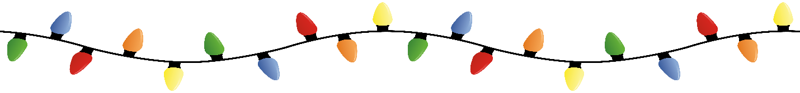
Please celebrate with
Dinner immediately following the
New Bern Christmas Flotilla
Saturday December 7th
At
The Harrison Center
311 Middle Street

Menu
Vegetable Crudités
Tossed Green Salad with Rolls and Butter
Honey Bourbon Glazed Pork Loin or Chicken Marsala
Braised Red Cabbage Green Beans
Mashed Potatoes Penne Mezzani
Holiday Cake
BYO Imbibes

Please respond by November 30th with menu choice and payment of $30.00 per person to:
Debbie Rodriguez
1200 Plantation Drive
New Bern, NC 28562

I (we) will attend the Flotilla Dinner:

Name:_________________________________________

Email address for confirmation:________________________________

Menu Choice____________ Menu Choice_____________

